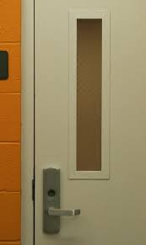
Fire Doors

What makes a fire door different?
As defined by the Architectural and Specialist Door Manufacturer Association (ASDMA) a fire door is:
“A complete installed door assembly comprising doorframe, door leaves, other panels, hardware, seals and any glazing that when closed is intended to resist the passage of fire and smoke in accordance with specified performance criteria. A fire door = a complete installed assembly.”
What does a fire door do?
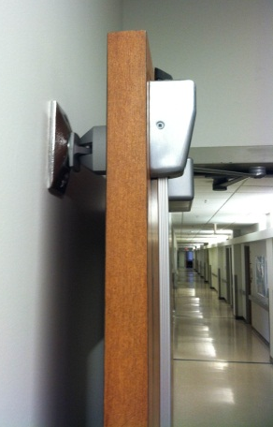
Along with self-closing ability, which prevents the spread of fire, these door can also block the movement of smoke, which in many cases can be equally or more dangerous than the fire itself.
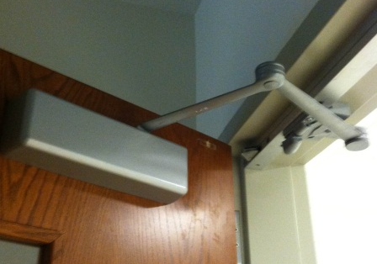
Fire doors are commonly held open by door retainers, as seen to the left, which allow for immediate closure during a fire.
The role of fire doors is to provide a safe and clear path for evacuation for the any person occupying the building during a time of emergency.

Safety Tips: Dos and Don’ts
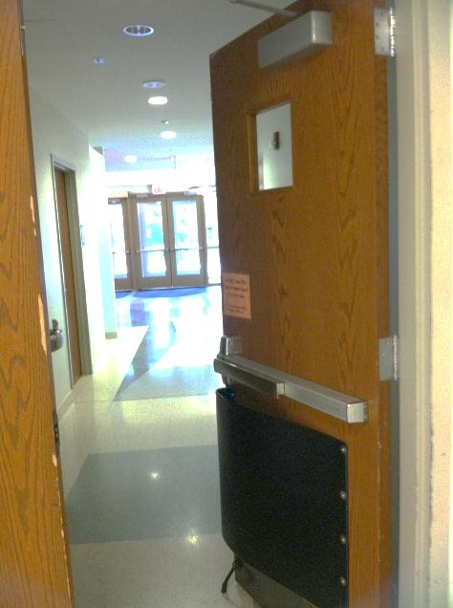
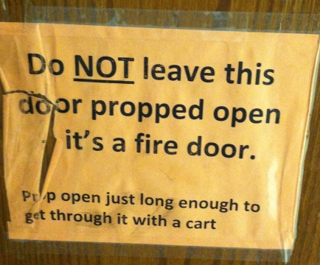
- In accordance with the William and Mary Fire and Life Safety Manuel,
“Do not obstruct exits and fire doors, fire alarm stations, fire extinguishers”

- This includes propping fire doors open with self-regulated objects (i.e. plastic stops, wood wedges, brick), preventing them from closing automatically in the case of an emergency or fire.

Fire Doors at ISC

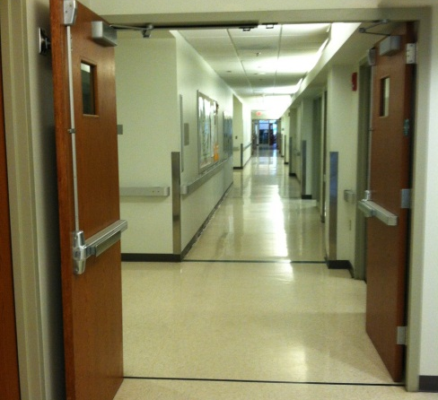
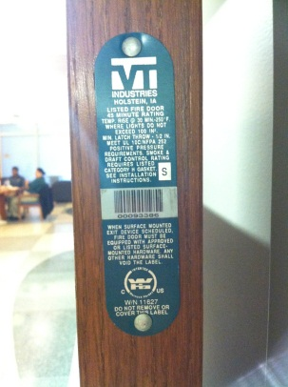
- On the 1st, 2nd, and 3rd floors VT Industries “S” rated fire doors can be found on the main hall that intersects classrooms and laboratories.
- The label seen on the right-hand side is attached to the fire doors on these floors.
- Approximately 2 sets of doors are on the first floor and one set is on the second and third floors along the main hallway.
- To the left, a set of fire doors from the first floor is pictured.
- These particular doors are 45-minute fire doors and are “S” rated which means that they have a fire-rated smoke gasket applied around the perimeter of the frame.
- On the ground floor the fire door is manufactured by UL and is a “Panic Hardware 99 Series.”
- These doors are designed to allow fast and unencumbered exit from a doorway.
- To operate “Panic Hardware 99 Series” Doors, simply push the rod, bar or other activator, instantly, the latch mechanism is retracted and you are able to push the door open.

http://www.safelincs.co.uk/the-role-of-fire-doors/
VT Industries Positive Pressure Fire Doors Brochure
http://www.jurispro.com/files/documents

